**LAB 1**

**Ajay Shete (abs717)**

**N19633252**

**DHCP Starvation Attack Procedure:**

1. First, switch on your ext-router using Vital and then initialize your Kali machine
2. Check the dhcp.leases file in /var/lib directory and delete all the leases except the Kali machine entry
3. Restart the ext-router if you deleted the leases.
4. Write a python code using ScaPy in Kali machine to create your DHCP starvation attack and start wireshark using terminal.
5. Once, the ext-router has rebooted, run the python file and check the dhcp.leases file periodically. You will see that the ext-router is assigning leases to the fake mac addresses.
6. If you don’t see any leases being assigned aside from the original Kali machine lease, then check your code and run again.
7. Once, all the 200 ips are assigned to the fake MAC addresses, initialize your XP machine and type ipconfig in your command prompt. (ifconfig for Ubuntu/Linux machine)
8. If no IP address is assigned to XP then you have successfully completed the DHCP starvation attack or else, rectify the problems in your code.

**Python Program:**

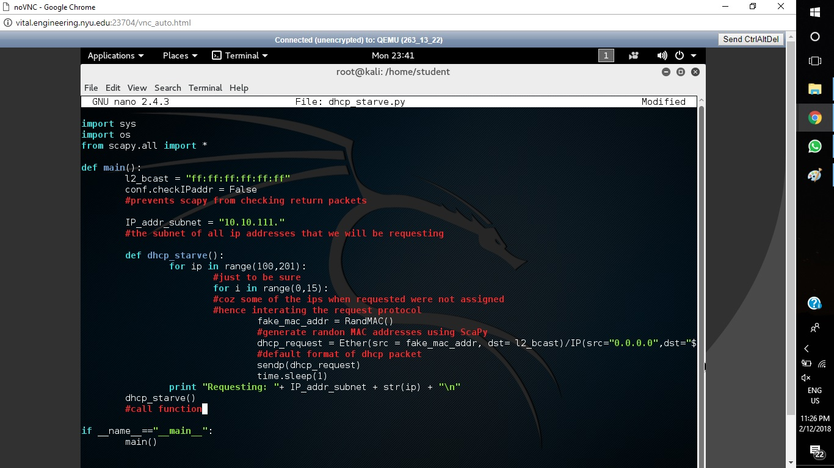

1. L2_bcast is the broadcast address as we must broadcast the DHCP request and the router that assigns DHCP leases will then reply to your machine’s request for an IP address.
2. Conf.checkIPaddr is assigned false to prevent ScaPy from checking the return packets and constantly keep sending DHCP request.
3. The subnet of all the IPs that the ext-router is giving out is 10.10.111.xxx, hence we are assigning the subnet to a variable IP_addr_subnet.
4. We will run our program to gain IP addresses from 10.10.111.100 to 10.10.111.200.
5. We will request the same IP address multiple times because the ext-router fails to simultaneously assign leases to all request. Earlier, I tried looping it 8 times but still, the router failed to assign leases to some of the DHCP request, hence I changed it to 15.
6. RandMAC() is a ScaPy function used to randomize the MAC address for each IP request.
7. For DHCP request we use the default command, which ask for a MAC address, for which we are giving the fake MAC address; destination address for which we are using the broadcast address. UDP request at the source and destination port. The BOOTP again switches the sender’s MAC address with the fake MAC address.

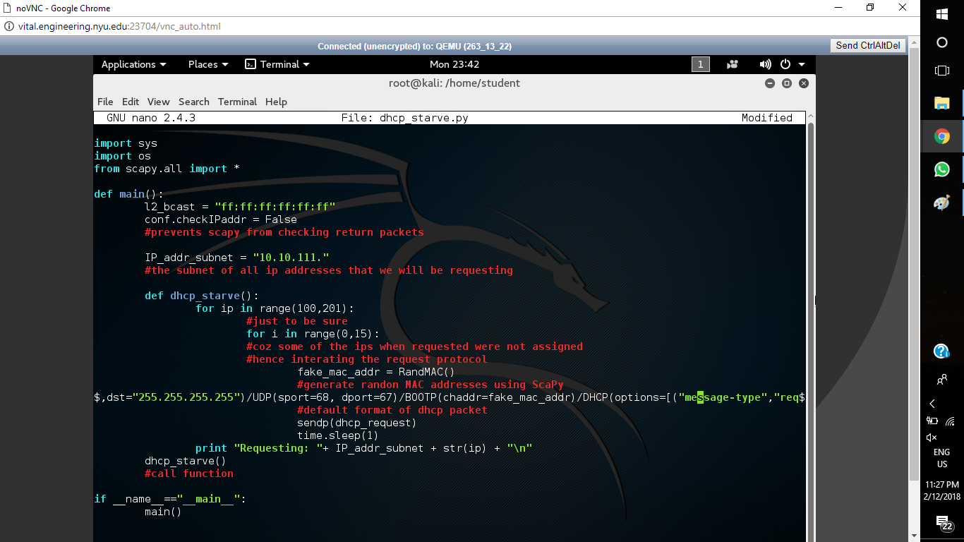

1. Message type will be a request as it is a DHCP request, the IP will be concatenated with the IP_subnet that we defined earlier; and finally, end.
2. Send this DHCP request.
3. Use sleep function to send the DHCP request at a certain interval of time.
4. Call the DHCP starve function.

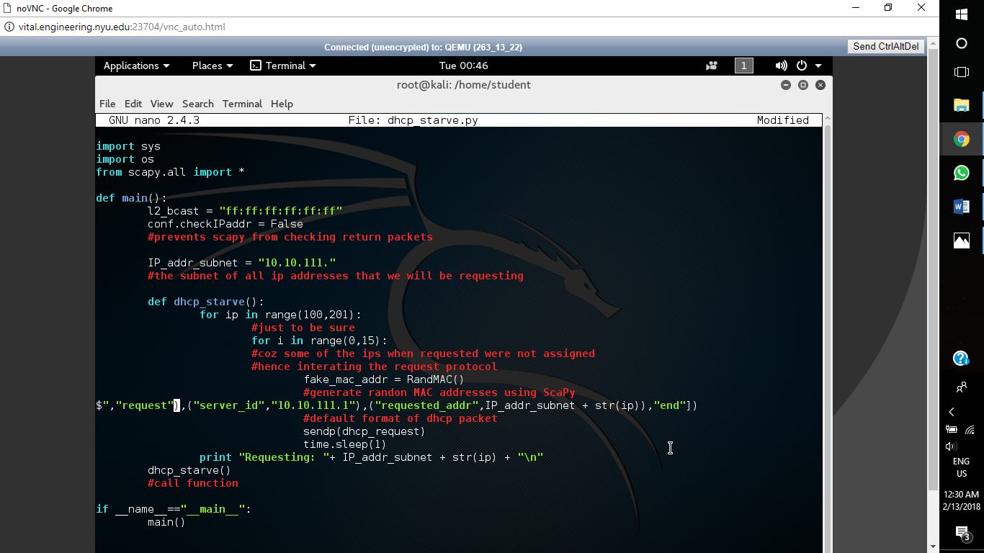

**DHCP Leases:**

***Before running program***

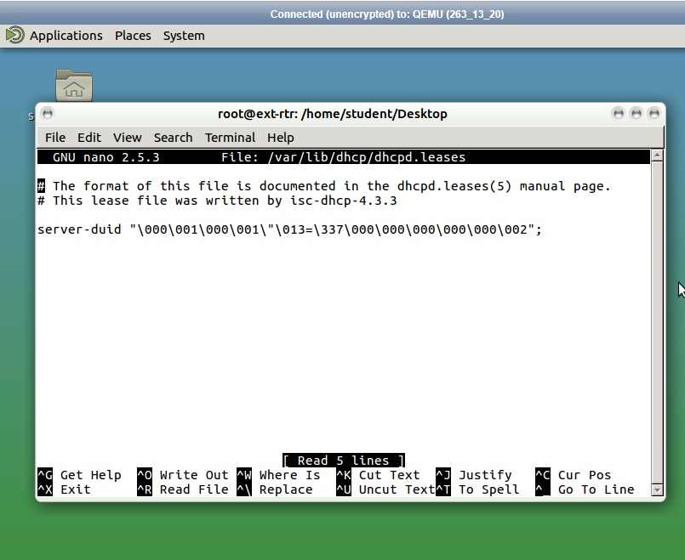

**Before Initialising Kali**

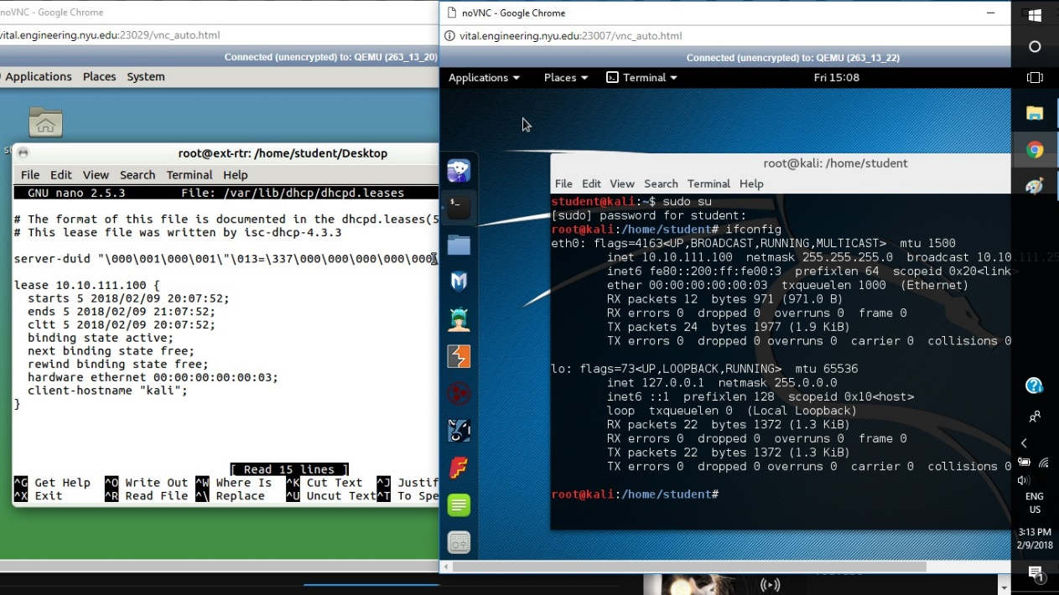

***After running the program***

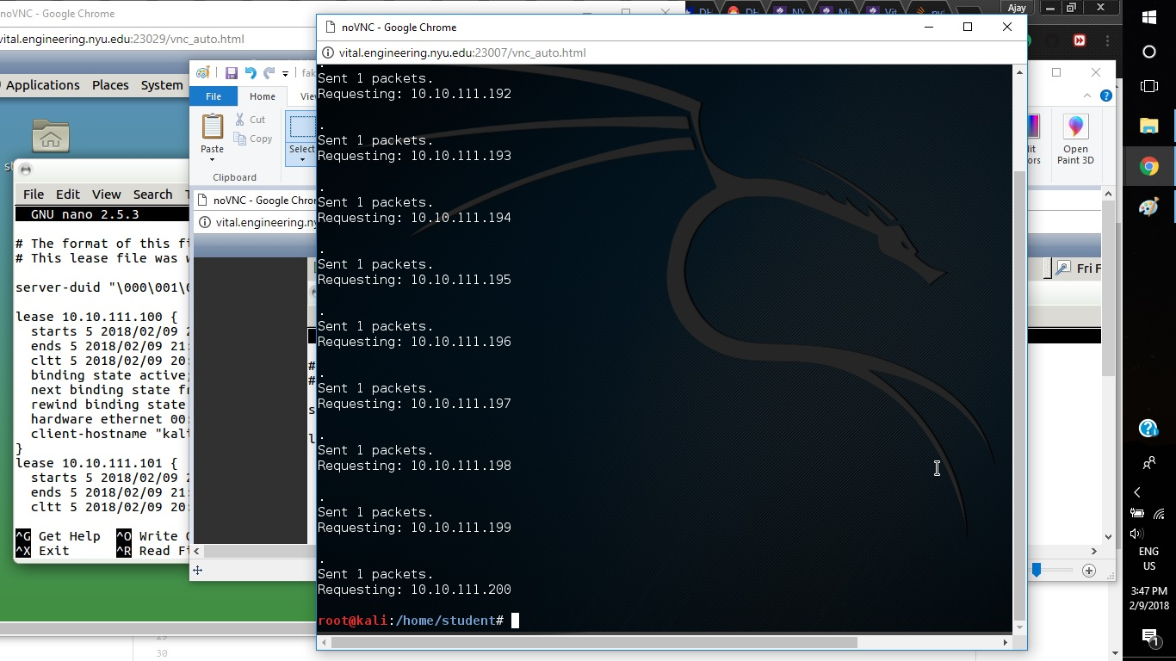

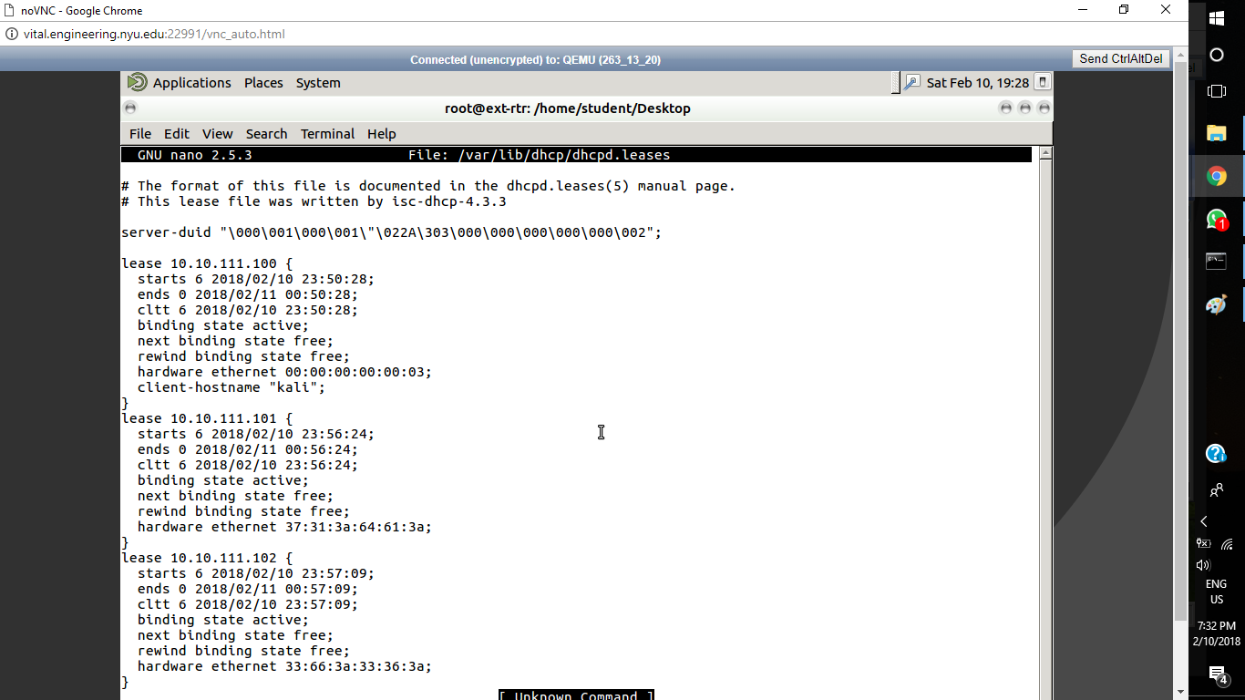

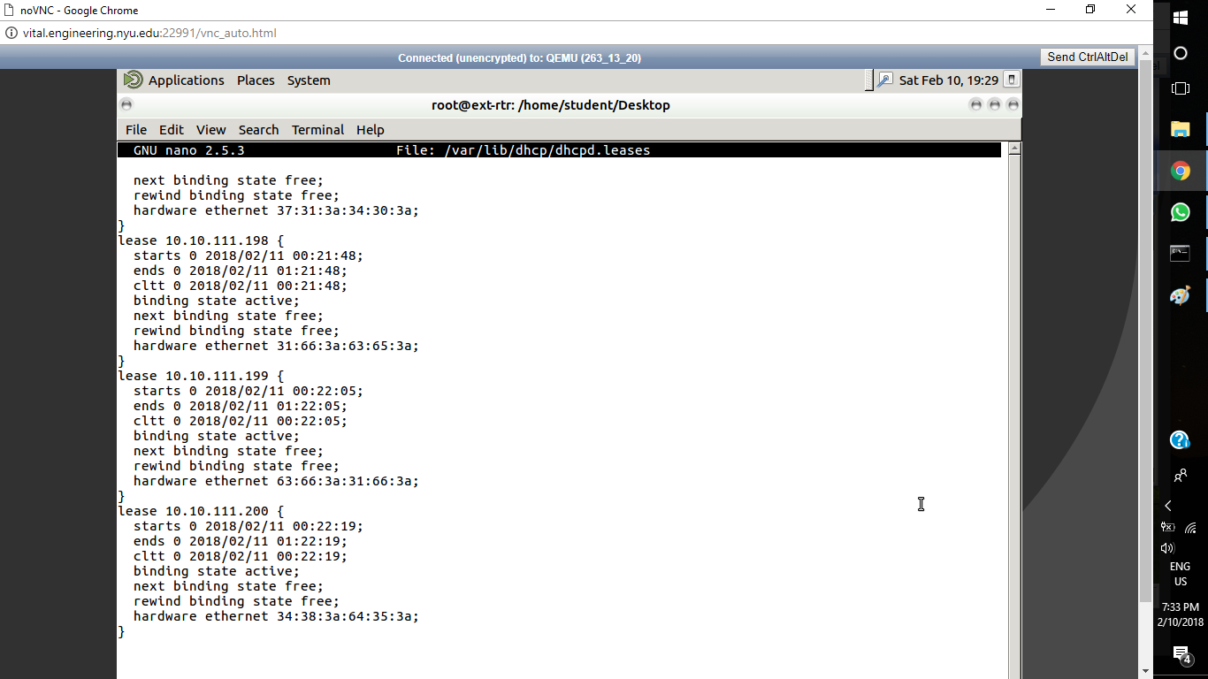

Assigned all IP address to fake MAC addresses

Additional Lease Screenshots: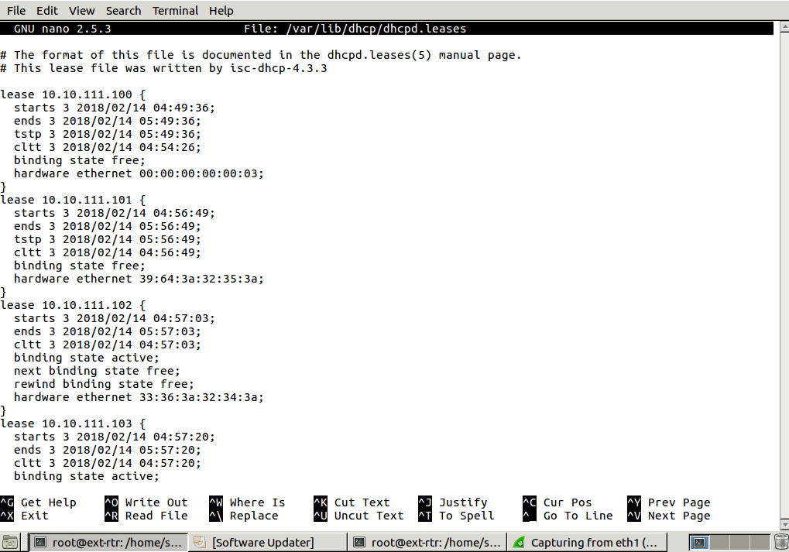

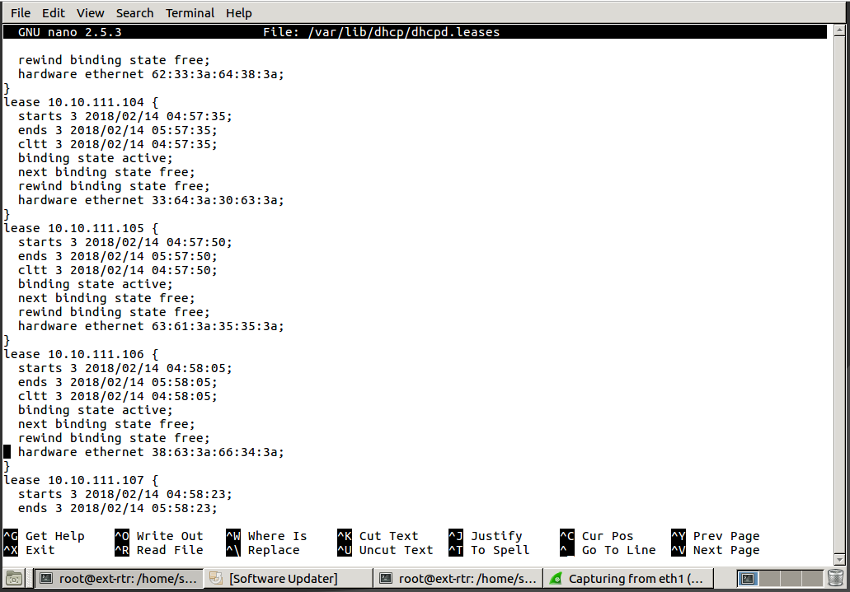

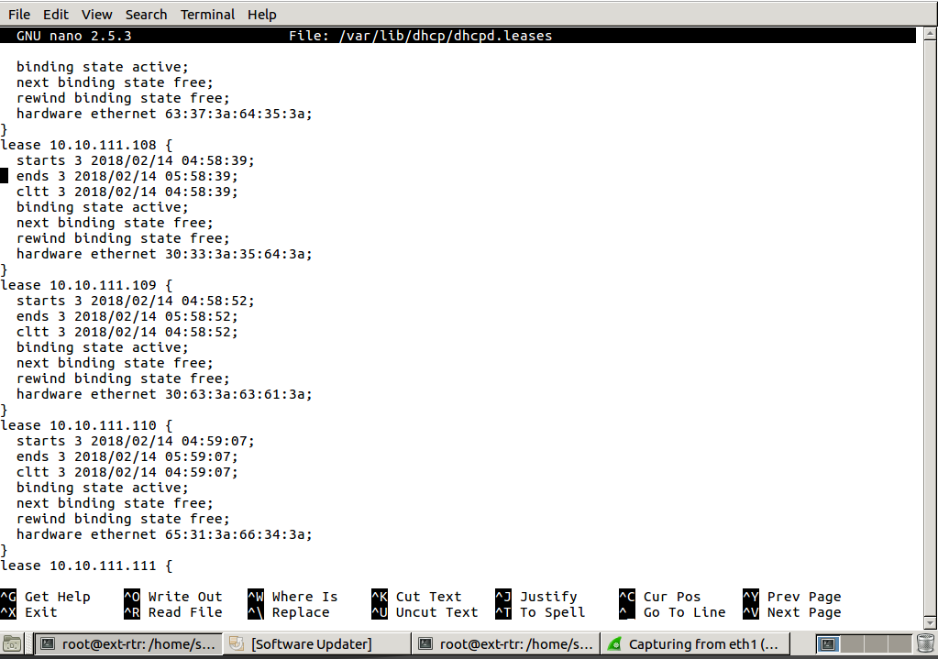

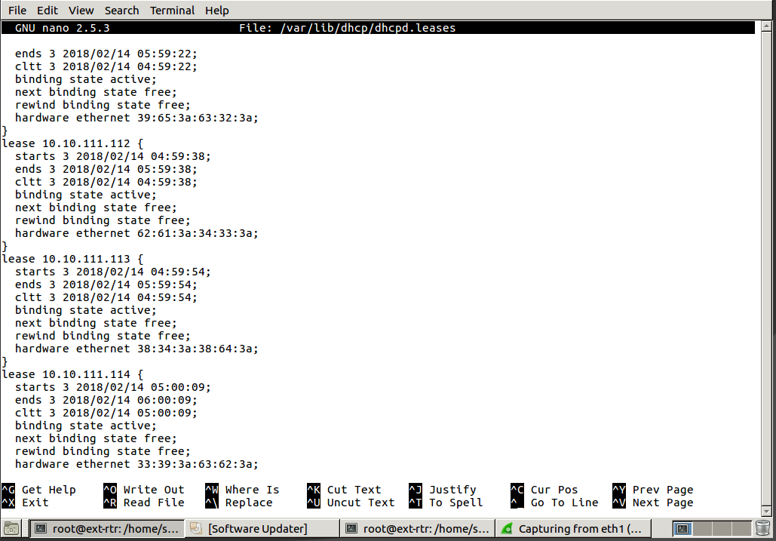

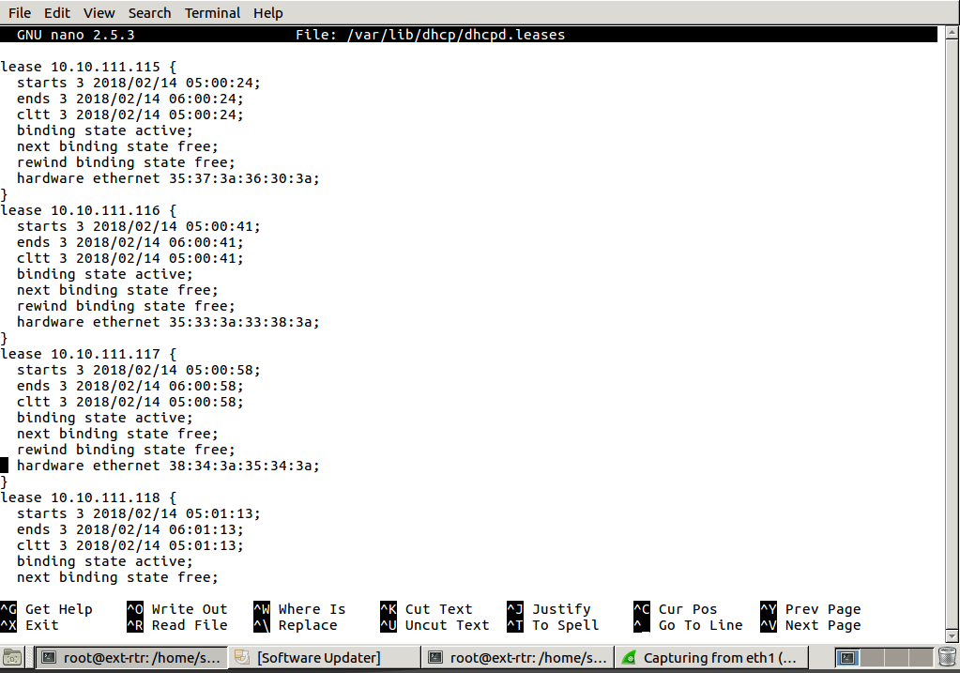

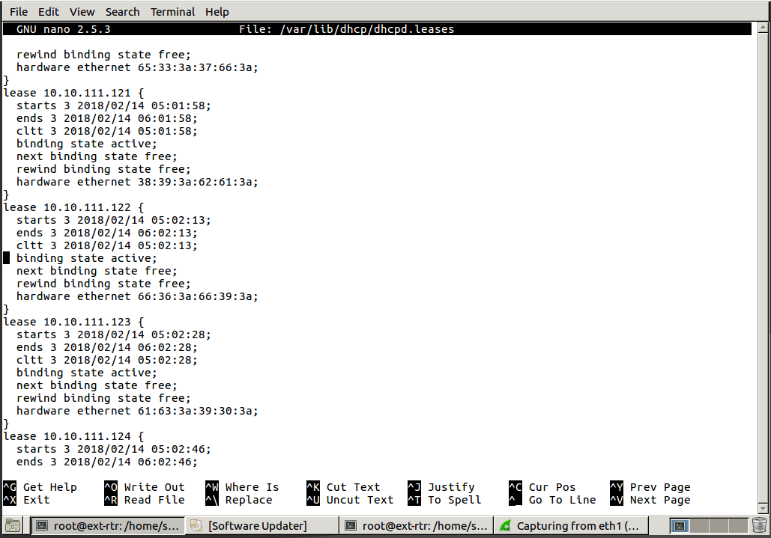

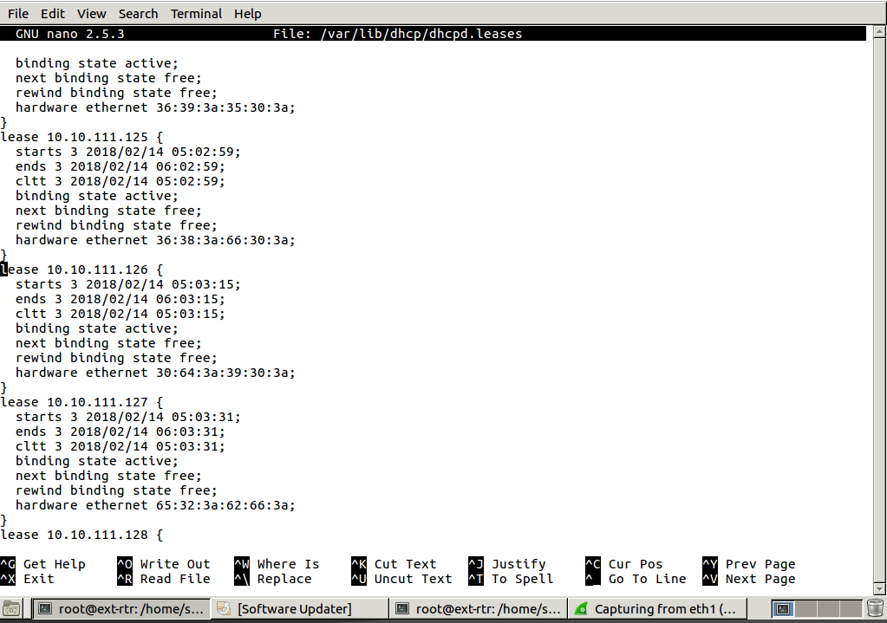

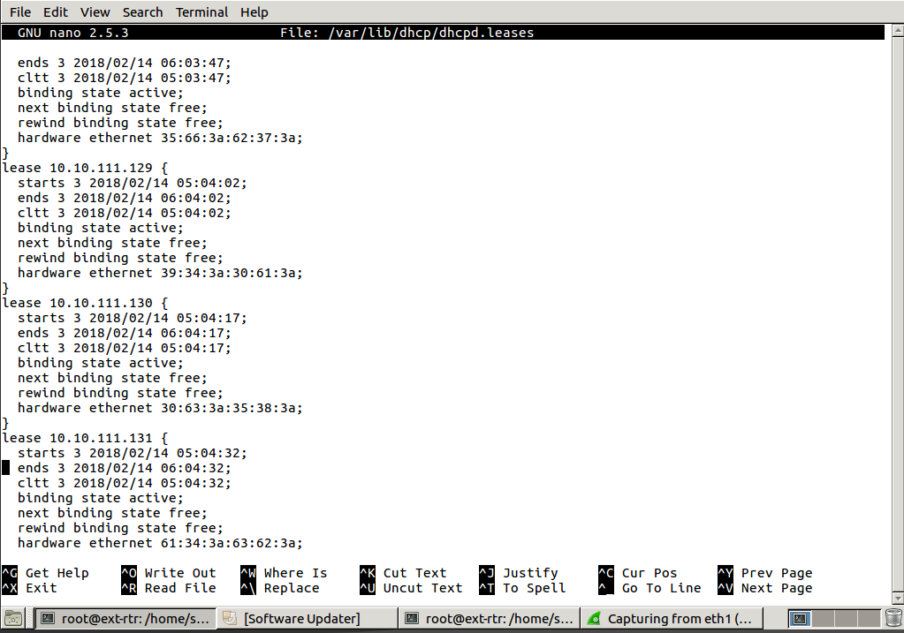

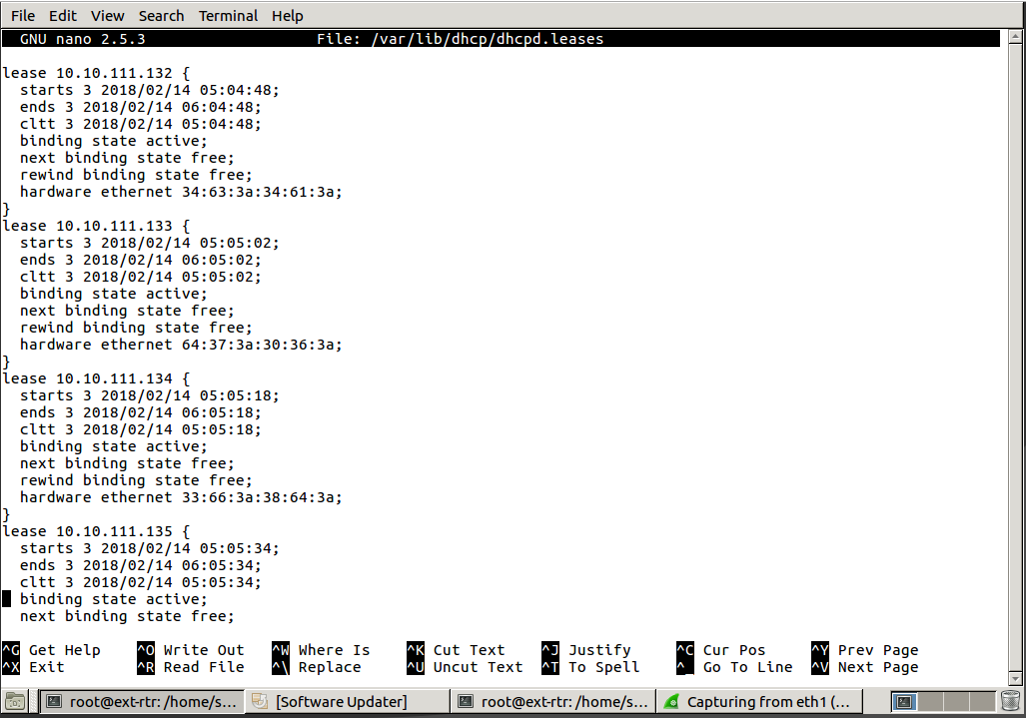

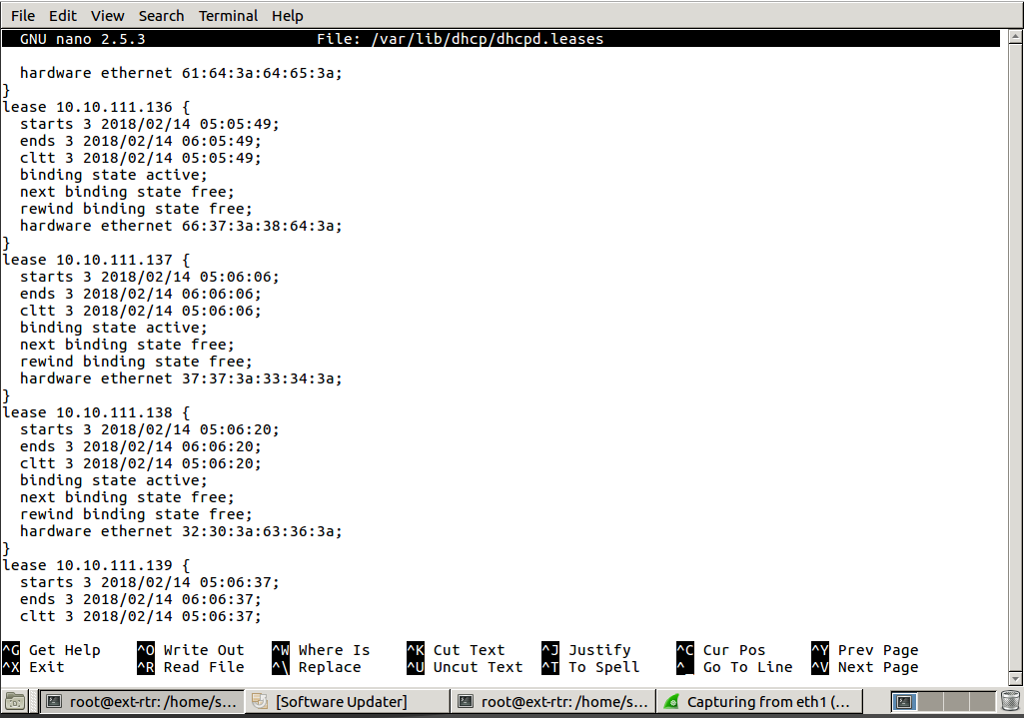

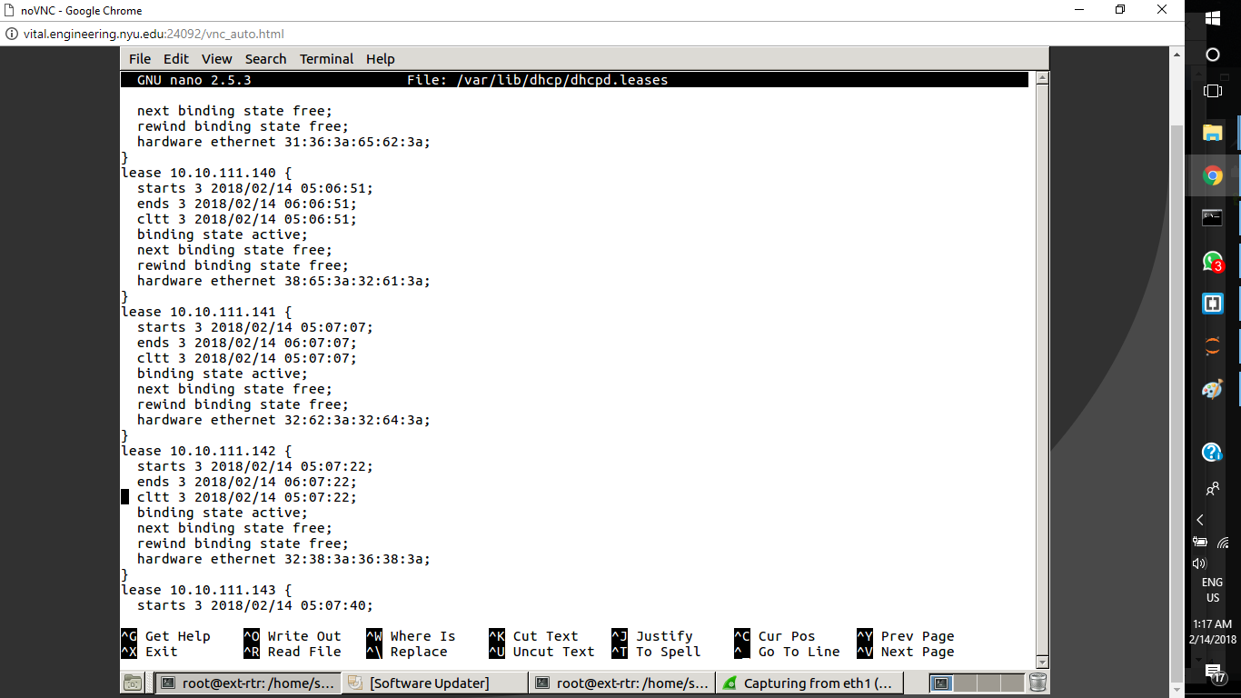

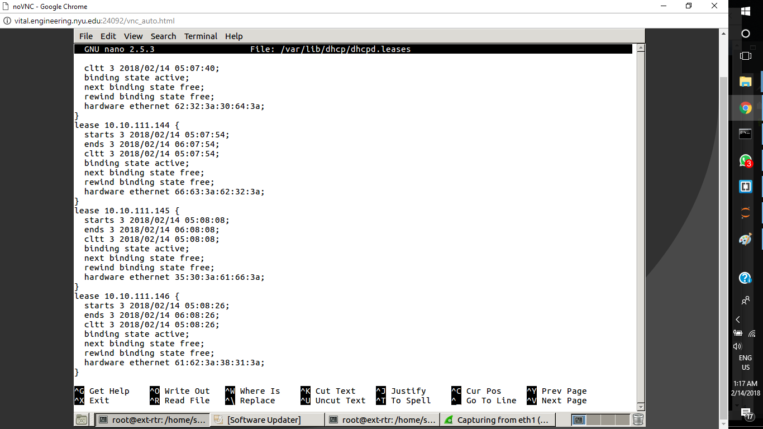

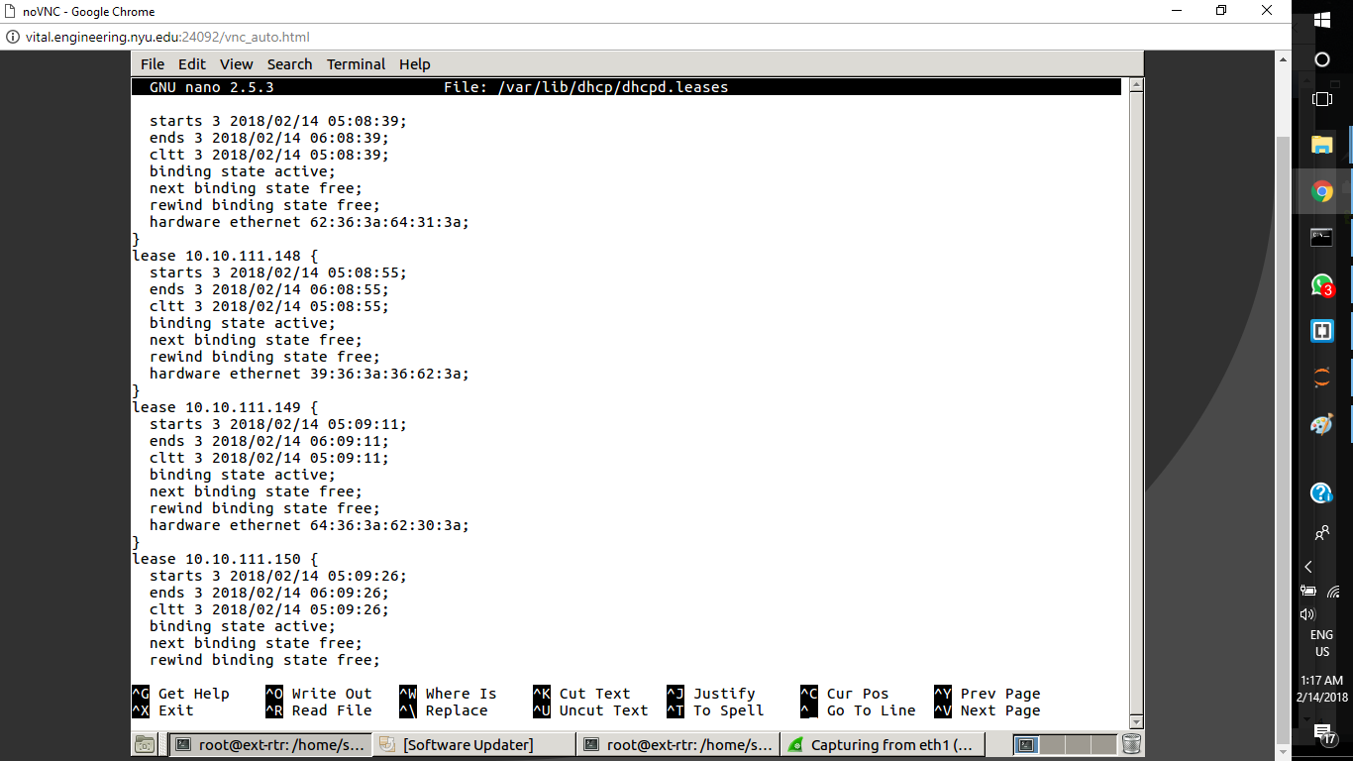

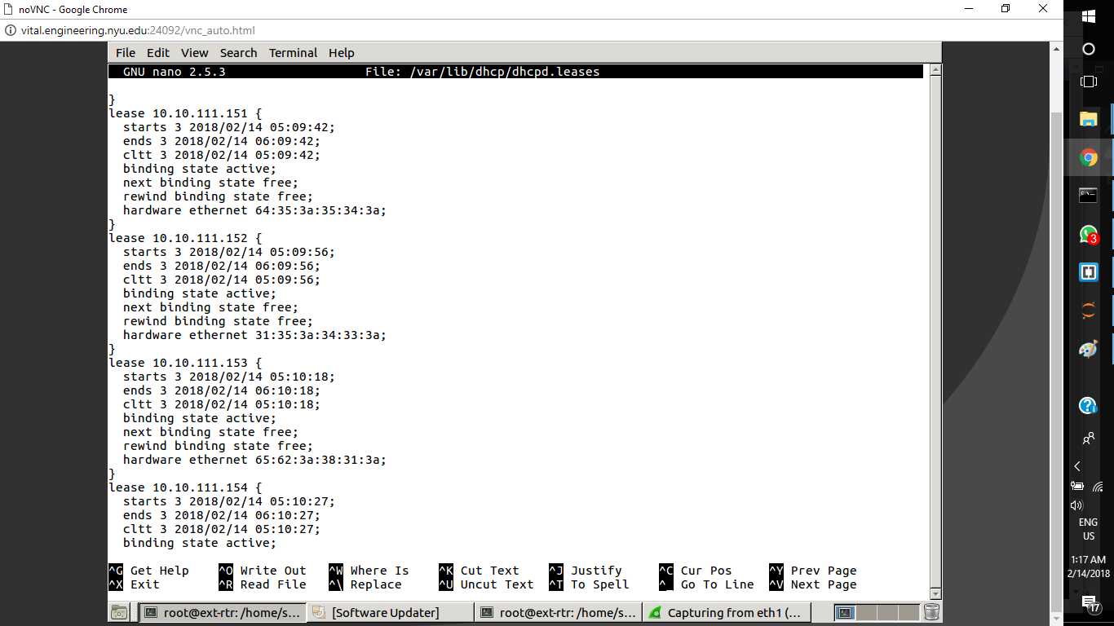

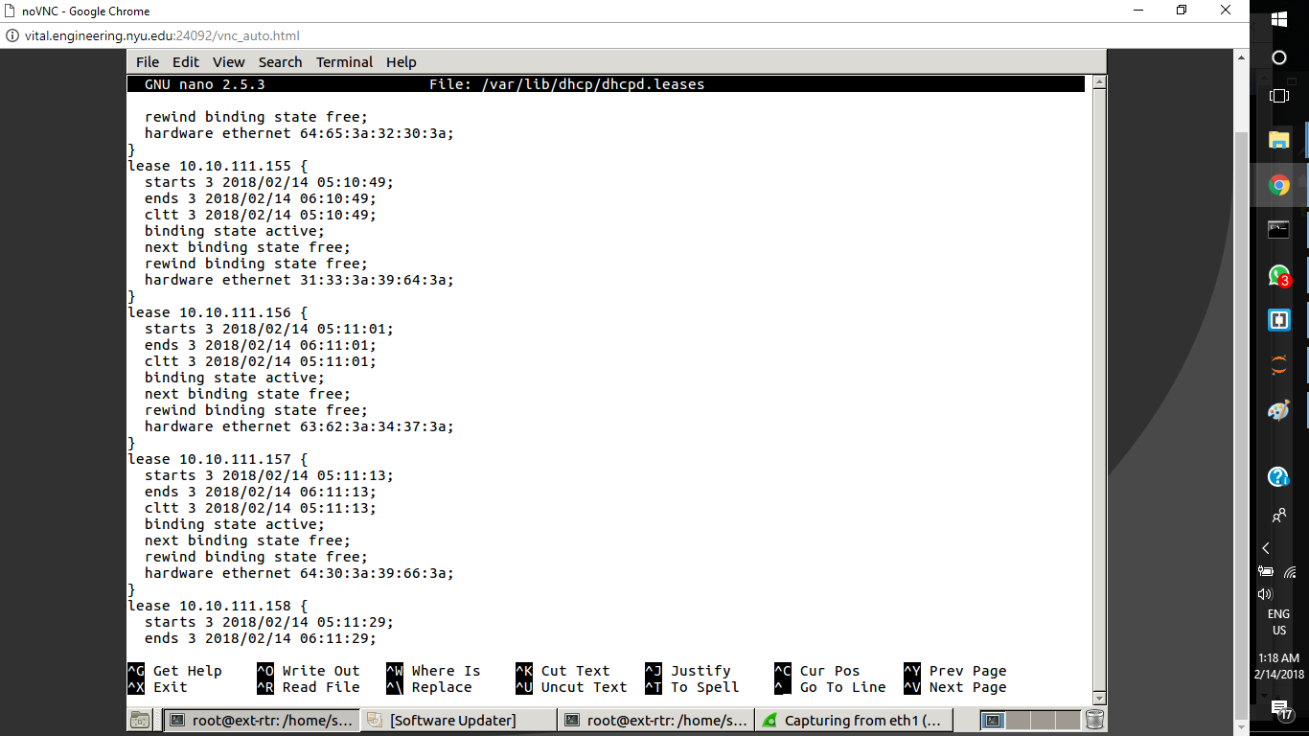

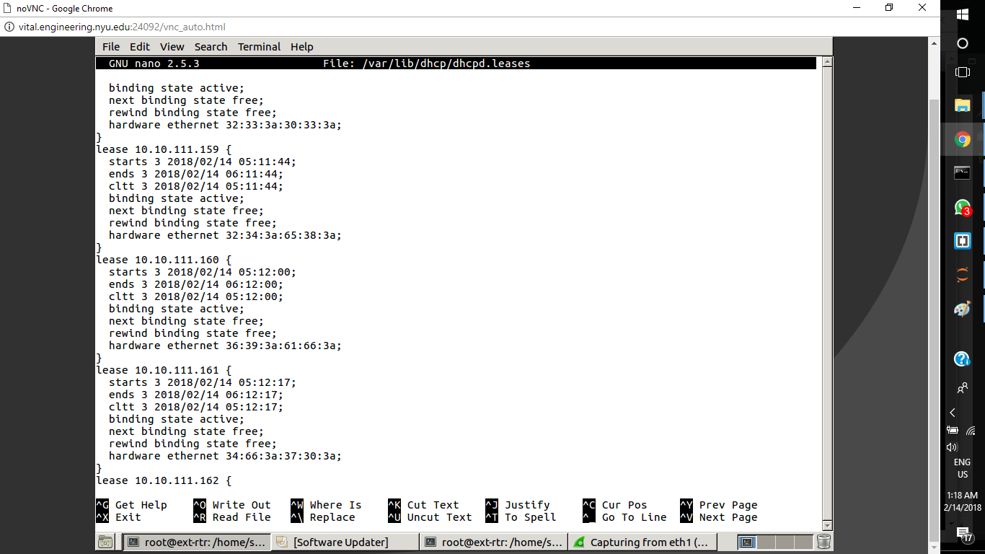

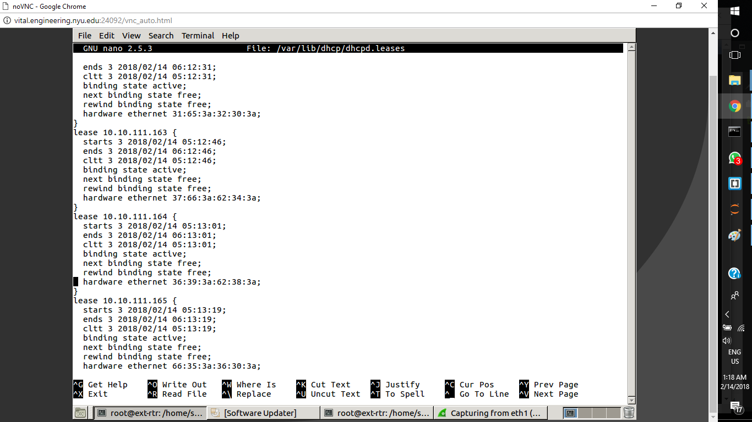

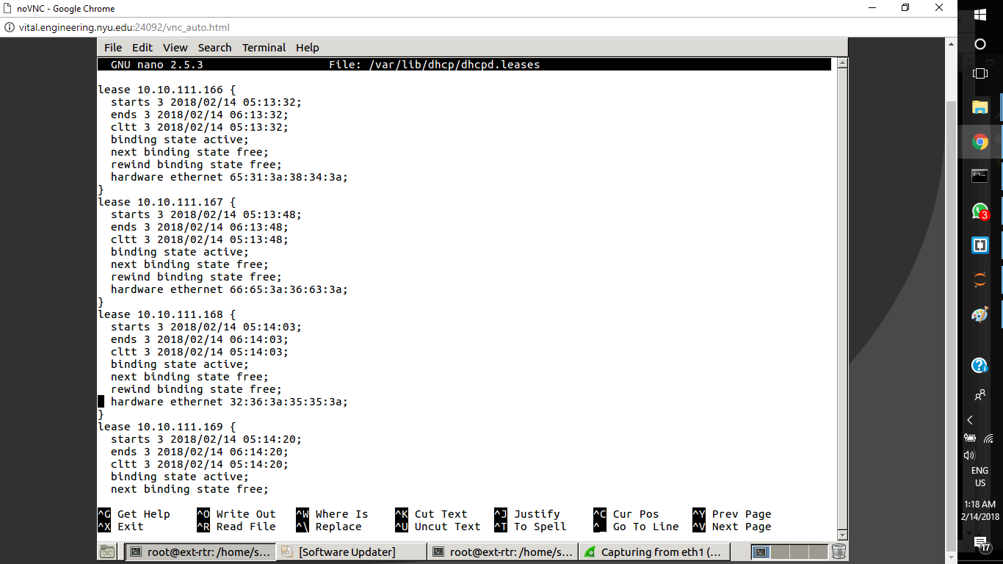

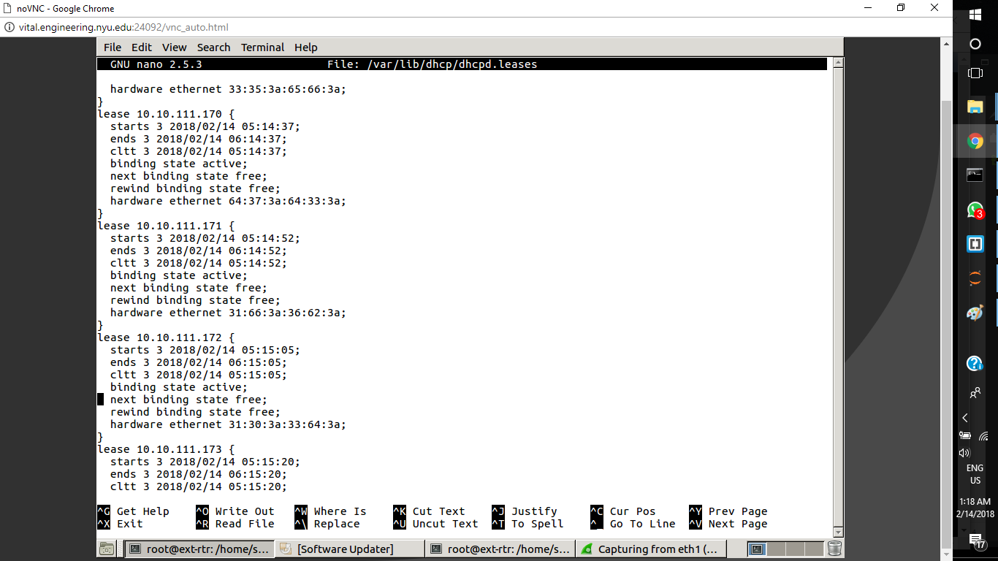

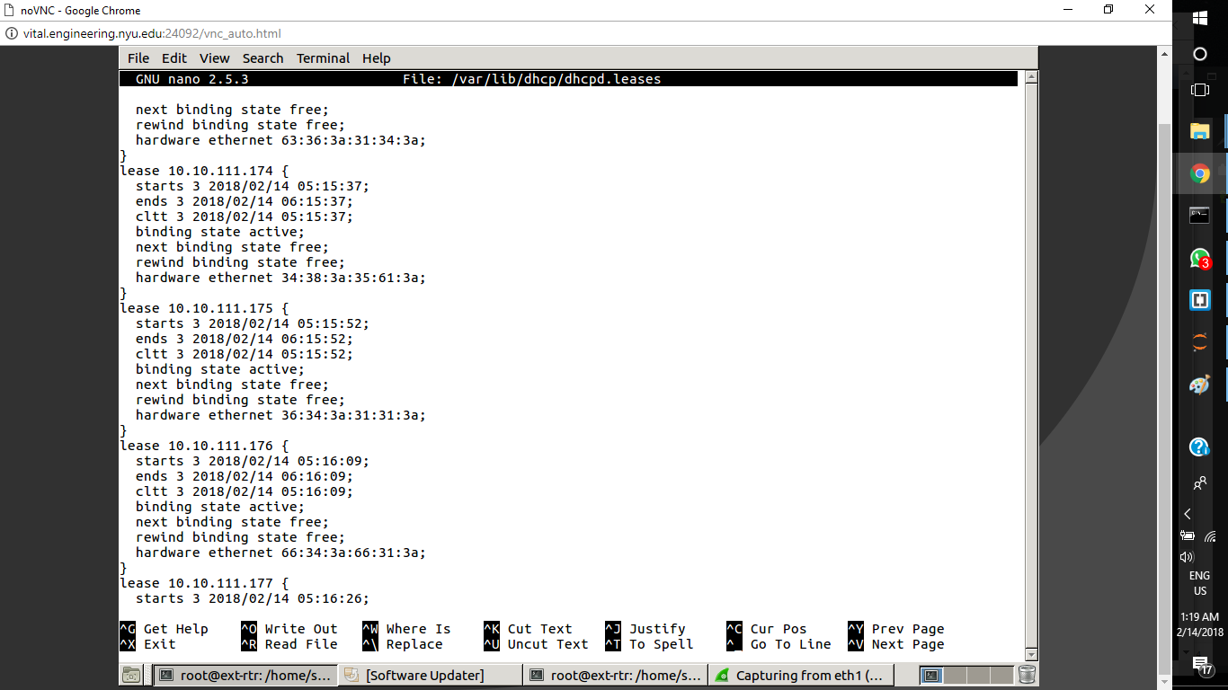

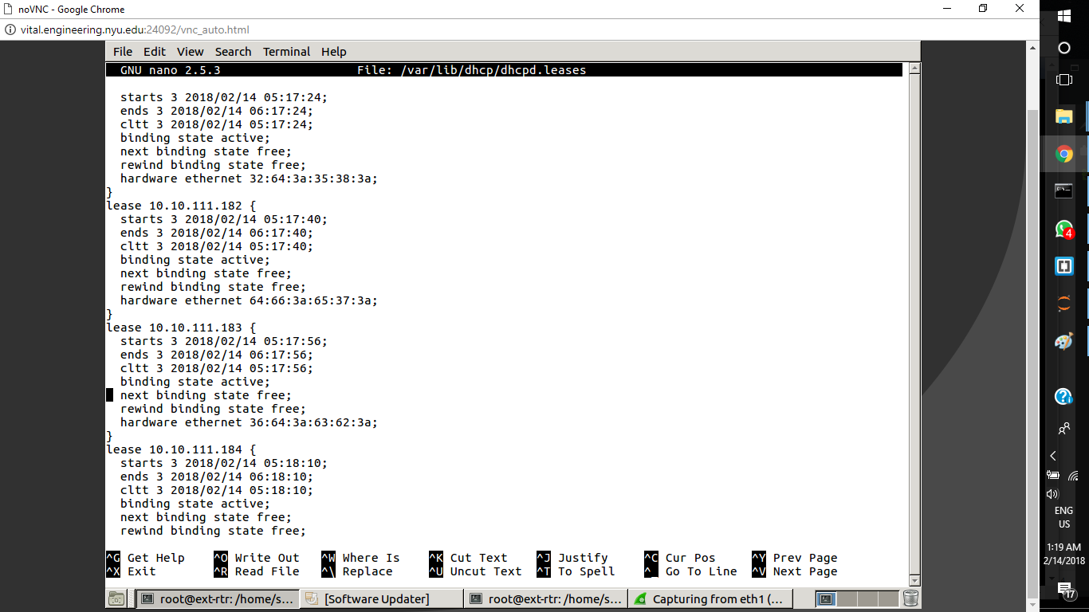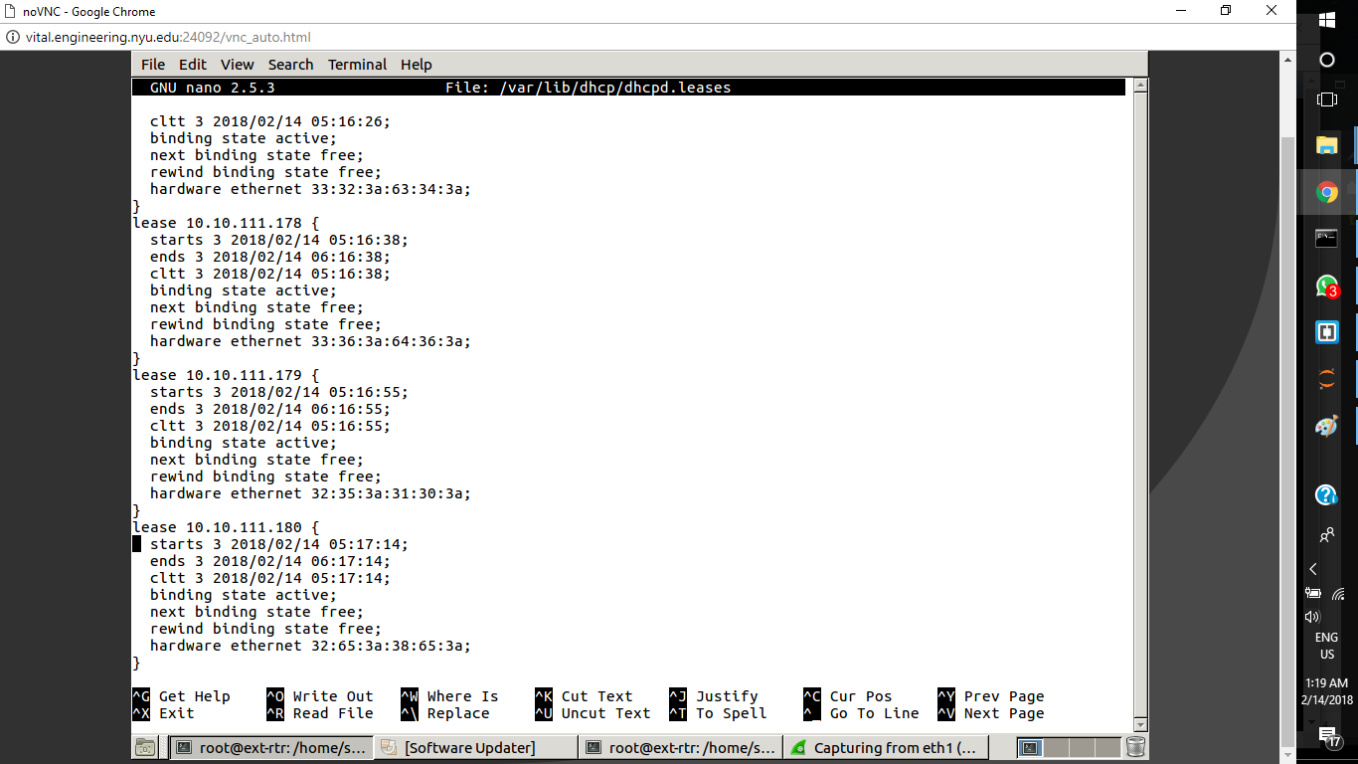

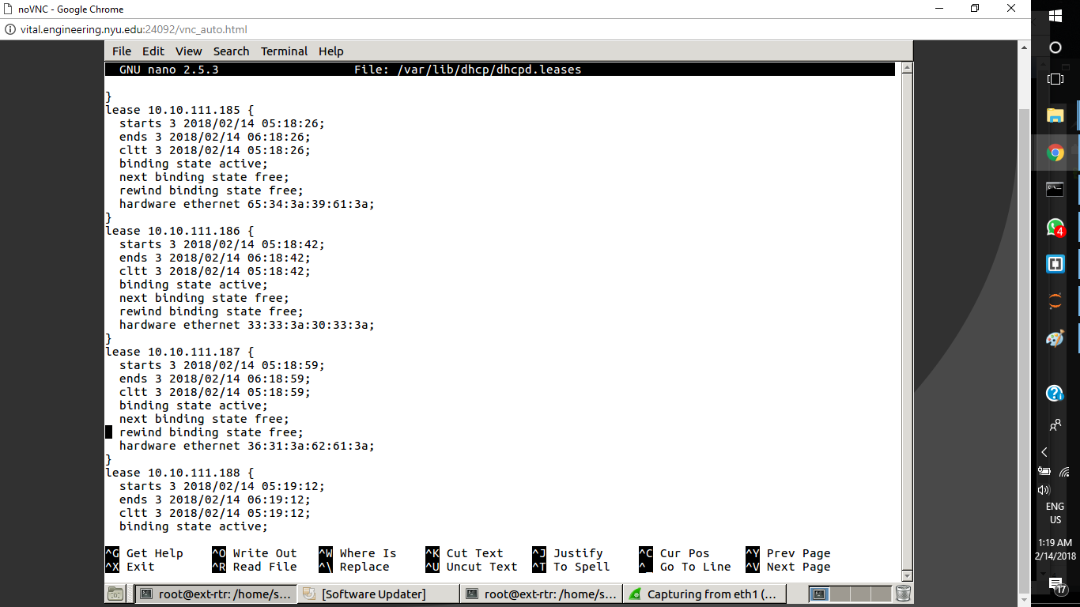

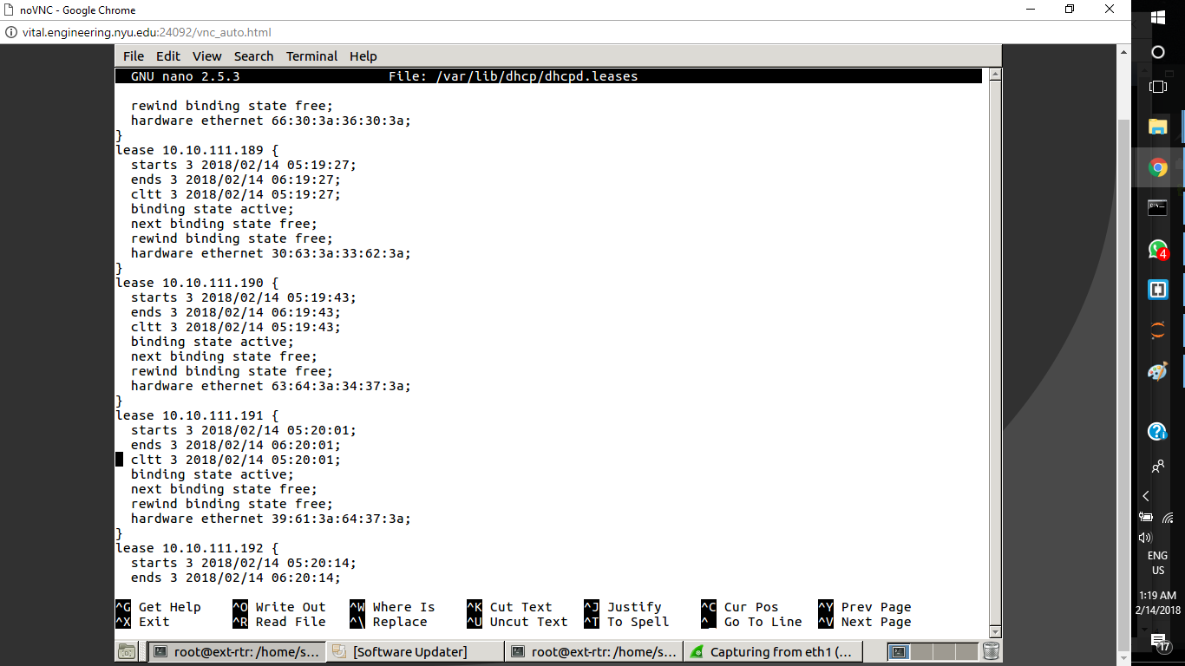

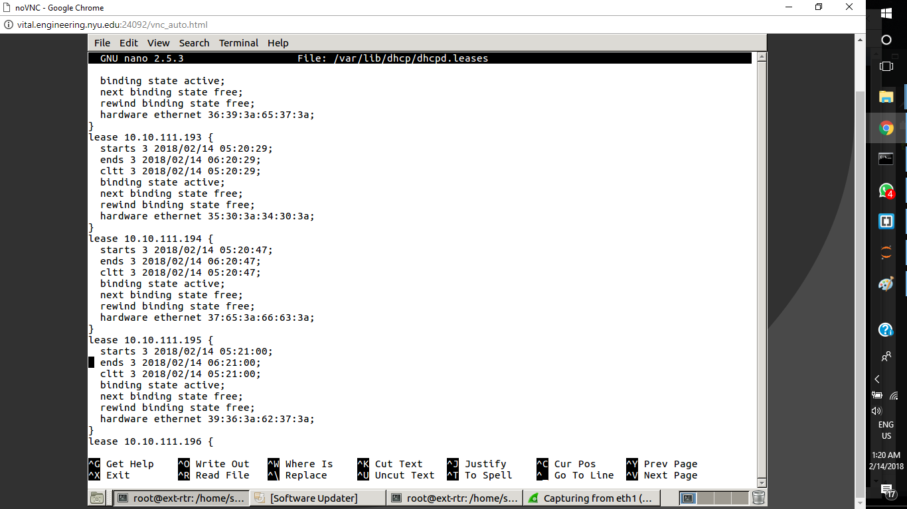

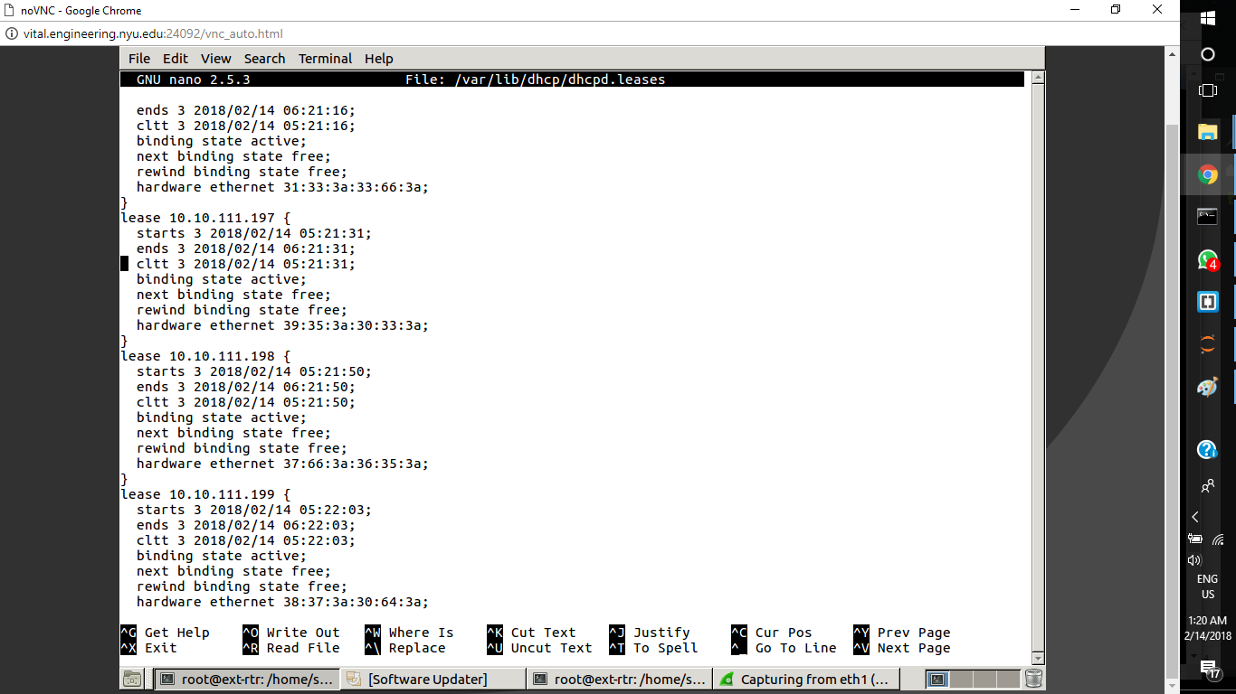

**Victim’s Machine (XP):**

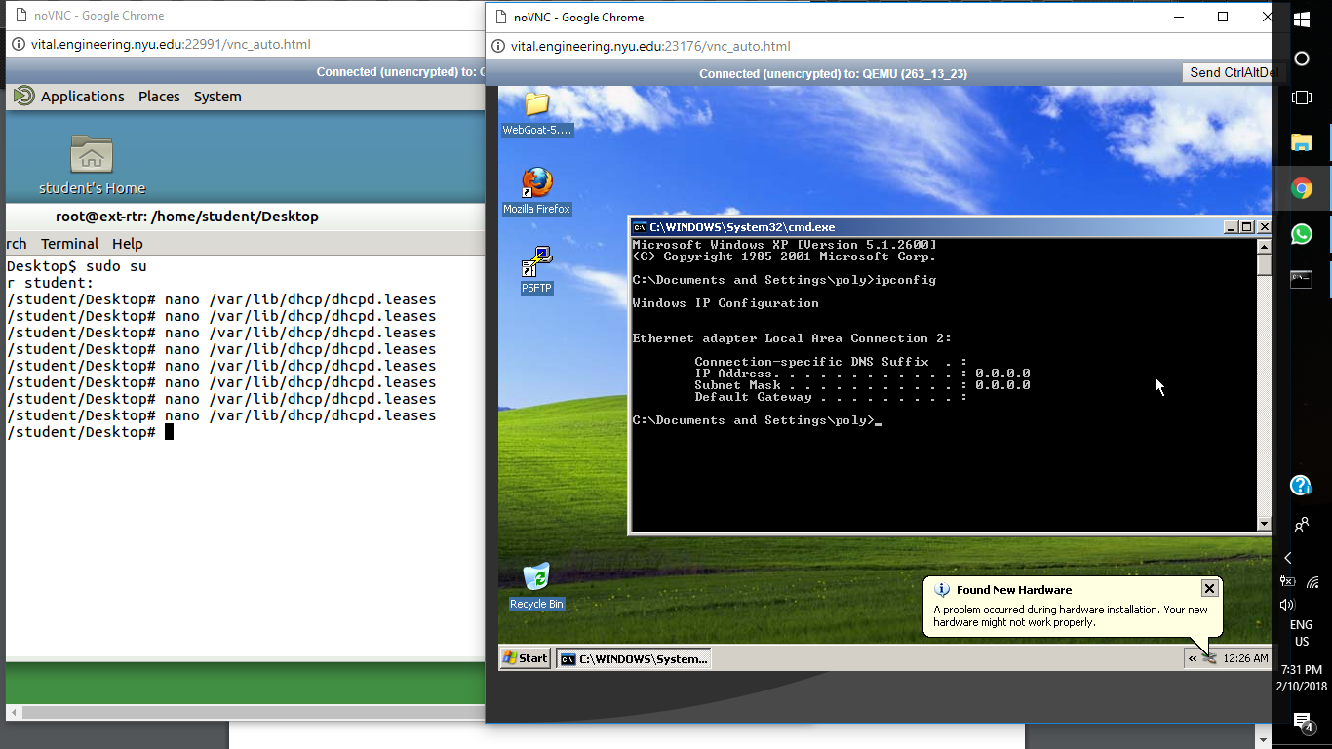

Since all the IP addresses have been assigned to fake MAC addresses, the ext-router cannot assign Windows XP an IP address, hence, the IP address is 0.0.0.0.

**Wireshark:**

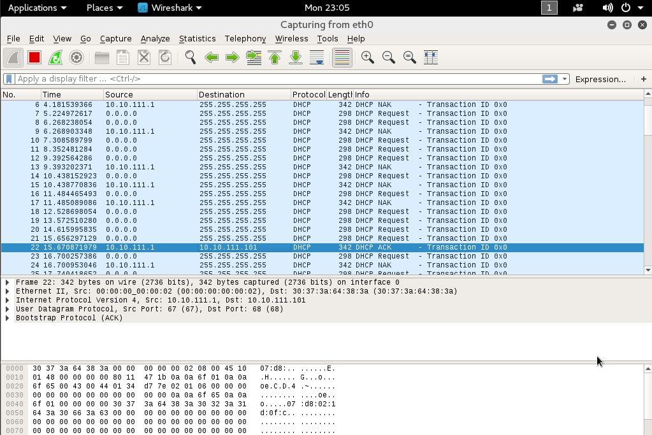

The wireshark report shows repeated DHCP request of the same IP address. We received a No Acknowledgement signal at first but then we finally get the Acknowledgement signal for the IP address that we request.

